**USECASE:**

* **A use case is a methodology used in system analysis to identify, clarify and organize system requirements.**
* **The use case is made up of a set of possible sequences of interactions between systems and users in a particular environment and related to a particular goal.**
* **The method creates a document that describes all the steps taken by a user to complete an activity.**

**ACTOR:**

**User: Represents individuals who use the WhatsApp application.**

**USECASE DIAGRAM:**

**Use case diagrams are usually referred to as behavior diagrams used to describe a set of actions (use cases) that some system or systems (subject) should or can perform in collaboration with one or more external users of the system (actors).**

**Register Account: The process of creating a new WhatsApp account.**

**Send Message: Allows a user to send a text message to another user or a group.**

**Send Media: Allows a user to send media files (images, videos, audio, documents) to another user or a group.**

**Create Group: Enables a user to create a new group and add other users to it.**

**Join Group: Allows a user to join an existing WhatsApp group if invited.**

**Block User: Lets a user block another user to stop receiving messages from them.**

**Unfriend/Leave Group: Allows a user to unfriend another user or leave a group.**

**Set Profile Picture: Enables a user to set or change their profile picture.**

**Set Status: Allows a user to set or update their status message.**

**Voice/Video Call: Allows a user to initiate a voice or video call with another user or a group.**

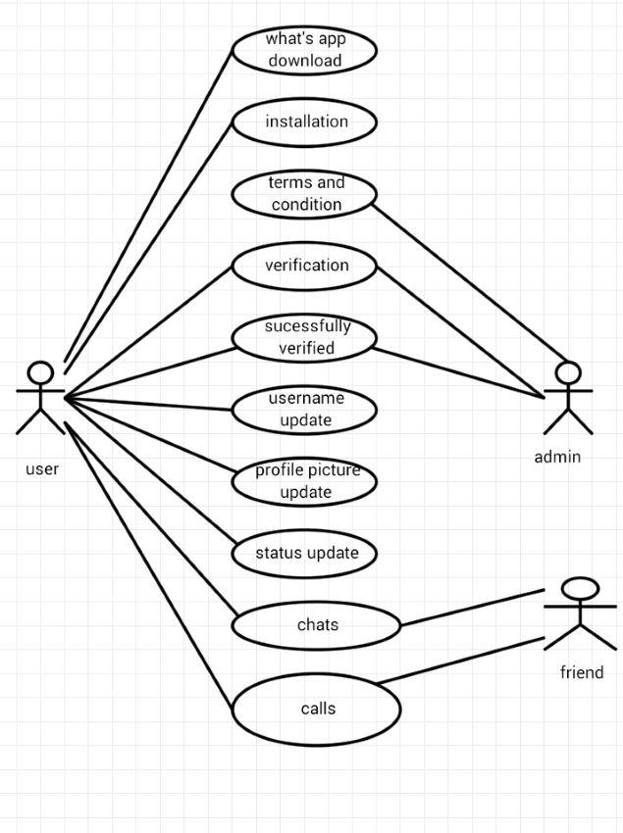

**USECASE FOR WHATSAPP:**

|  |  |  |
| --- | --- | --- |
| **USECASE** | **ACTOR** | **DESCRIPTION** |
| **LOGIN** | **ACTOR** | **Login**  **Enter the Mobile number**  **Enter to Mobile number to generate OTP** |
| **WHATSAPP DETAILS** | **ADMIN** | **Edit account**  **Delete account**  **View actor account details** |
| **ACCOUNT DETAIL** | **ADMIN,ACTOR** | **Add account**  **Delete account**  **View chat and status**  **View history of an account** |

**SCENARIO:**

|  |  |  |
| --- | --- | --- |
| **S.NO** | **ACTION** | **SOFTWARE REACTION** |
| **1.** | **Actor connecting to corresponding account through ATM card** | **System request the following data is from**   * **ACCOUNT** * **ATM CARD** * **MOBILE NUMBER** |
| **2.** | **Actor Giving input by entering the pin code** | **The ATM machine verify that the above 3 items have been filled out**  **If any data is missing the machine warns the actor and the scenario continues with  #1**  **If all data has been entered, the Machine asks the actor to verify the their transaction**  **If the customer indicates they would like to cancel the scenario ends here.**  **If the Actor indicates that their transaction is not correct, the scenario continues with #1** |
| **3.** | **Actor confirms that their transaction is correct** | **If the Actor says their transaction is incorrect,the scenario returns to #2**  **If the Actor confirms their transaction,the Machine ask the Actor To proceed further by asking to enter the choice cash withdrawal,saving or balance enquiry.** |